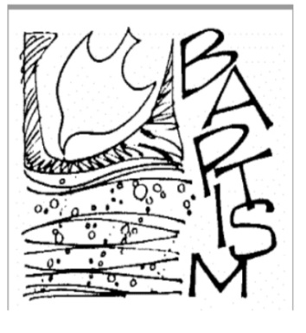
Register Your Child for Baptism

Questions regarding the Sacrament of Baptism may be directed
to the to the parish office at 706-648-2599.
Preparation for the Sacrament of Baptism is the first step in your child's faith life. All parents wishing to have their child receive the Sacrament of Baptism must attend a Baptismal Preparation class. Please schedule your class with Bernadette Luger.
To register your child for the Sacrament of Baptism you must meet the following criteria:
You must live within our parish boundaries. If not within our parish boundaries, you must be registered and active at Saint Peter the Rock. Parents must practice the Catholic faith to the extent that the Church has a founded hope that you will raise your child in the faith.
Both parents must attend a Baptismal Preparation Class. Once you have completed the Baptismal preparation class you may schedule your Baptism with the parish office.
If you have attended a Baptismal Preparation class for an older child within the last two years you are invited to attend but the class is not mandatory.
Godparents must be fully initiated Catholics who are living in communion with the Catholic Church. We require a letter from their parish indicating that they are qualified to act as godparents. If there are two godparents, one must be male, and one female. (A non-Catholic of either gender can stand as a Christian Witness to a baptism along with a Catholic godparent.)
Parents with children 0-7 years old should contact Bernadette Luger at ext. 101 for important information.
The following information is required for the Sacramental register and to complete a Baptismal certificate. Please complete the entire form. Once this has been submitted to our office you may call to schedule your Baptism.

Full Christian Name of Child (as it appears on birth certificate)
First Name of the Child
Middle Name of the Child
Last Name of the Child
Your Home Address
City, State, Zip
Phone Number
Email Address
Child's Date of Birth (MMDDYYYY)
Current Age of Child
Sex of Child |  |  | Male |  |  |  |  |  |  |  |  |  |  | Female
Place of Birth (City, State)
Country of birth
Father's Full Legal Name
Father's Religion
Mother's Full Maiden Name
Mother's Religion
Were parents married by a Catholic Priest? |  |  |  |  |  |  |  |  |  |  |  |  |  |  |  |  |  | Yes |  |  | No
Godfather
 | (name as it is to appear in Sacramental Register and on Certificate)
Is this Sponsor Catholic? |  |  |  |  |  |  |  |  |  |  |  | Yes |  |  |  | No
Godmother
 | (name as it is to appear in Sacramental Register and on Certificate)
Is this Sponsor Catholic? |  |  |  |  |  |  |  |  |  |  | Yes |  |  |  | No
Will either sponsor be represented by Proxy? |  |  |  |  |  |  |  |  |  |  |  |  |  |  |  |  |  |  | Yes |  |  |  |  |  | No
Name of Proxy
Was this Child Privately Baptized? |  |  |  |  |  |  |  |  |  |  |  |  |  |  | Yes |  |  |  | No
Is this child adopted? |  |  |  |  |  |  |  | Yes |  |  |  |  |  | No
 |  |  |  |  | If yes, please give date of final decree (mm/dd/yyyy)
 |  |  |  |  | and
 |  |  |  |  | Court where decree was issued
 |  |  |  |  | this is required by Canon Law for the sacramental register. A copy of this decree must be submitted to the Parish Office.
Parish envelope number

